PIXELPOPS! 2011 presents Performance From Far Away – An exhibition featuring a large number of video performances and performance videos!
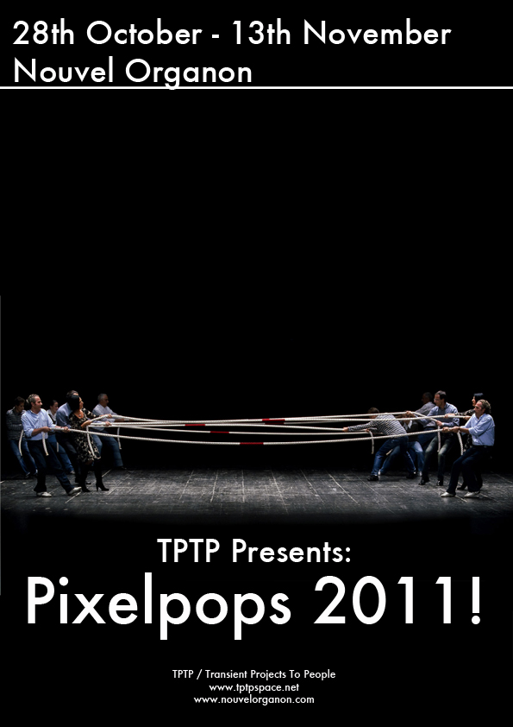
Photo: From the video “Déjà Vu” by Filippo Berta
The EXHIBITION OPENING takes place Friday Oct 28, 2011 from 7pm to 10pm (19h – 22h).
Afterwards there’ll be a little AFTER PARTY until midnight, where WITTY BANTER invites you to perform your most wicked dance steps!
LIVE-STREAM: The opening will be live-broadcasted on this webpage, so even if you’re not in Paris, you can somehow take part…
Artists
Around 200 submissions were received for the Open Call, and the selected artists are:
Agnieszka Fluder (Krakow/PL)
Anna van Stuivenberg (Eemnes/NL)
Andrew Binkley (Honolulu/USA)
Baden Pailthorpe (Paris/FR)
Bang Geul Han (Potsdam/USA)
Betty Boehm (Berlin/DE)
Carlos Noronha Feio (London/UK)
Dovrat Meron (Berlin/DE)
Dwayne Butcher (Memphis/USA)
Edin Baric & Judith Lomba (Hannover/DE)
Edward Salem (Beirut | LB)
Elisa Fernández Arteta (Pamplona/ES)
Filippo Berta (Bergamo/IT)
Francesca Fini (Roma/IT)
Ghazaleh Abassalian (Amsterdam/NL)
Giorgio Sadotti (LONDON/UK)
Jean-Michel Rolland (Epinay-sur-Orge/FR)
Karin Felbermayr ( Berlin/DE)
Kenji Ouellet (Berlin/DE)
Mario Asef (Berlin/DE)
Maya Quattropani (Torino | IT)
Michel Platnic (FR)
Miss Enabyme (Berlin/DE),
Morrisa Maltz (Los Angeles/USA)
Nicholas Fraser (Brooklyn/USA)
Nisha Duggal (London/UK)
Tellervo Kalleinen & Oliver Kochta-Kalleinen (Helsinki, FI)
Paul Wiersbinski (Stralsund/DE)
Roy Menachem Markovich (Tel Aviv/ISRAEL)
Sigmund Skard (Valevag/NO)
Signe Vad (Copenhagen/DK)
Simona da Pozzo (Milano/IT)
Stefan Riebel (Berlin/DE)
Steven Pedersen (Potsdam/DE)
Svetlana Ivanova (Berlin/DE)
Wyatt Niehaus (Cincinnati/USA)
Yael Schmidt (Tel-Aviv/IL)

